09/10/2025 — Scan → 3D in minutes
Why are children’s-book AR experiences still a “studio production”? We want something anyone can do: point the phone at a picture, take a single photo, wait a short moment, and then see that character pop up on the same page in AR. No Unity scenes, no 3D tools, no coding for end users. Just point → click → wait → play.
What we want people to get out of it
- Exploration: characters “rise” from the page so you can walk around them.
- Creativity without overhead: authors and illustrators add a new layer without hiring a 3D team.
- Scale: any clear, flat 2D image can become a trigger.
The first working ship (end-to-end flow)
- Tap Generate.
- The app captures one high-quality photo of the page.
- We upload that photo to an image-to-3D service (Meshy) and poll for progress.
- When the GLB is ready, we download and load it.
- We anchor the model on the same 2D page using AR image tracking. The camera must see the same picture again for the model to snap into place.
How we wired the scene (first iteration)
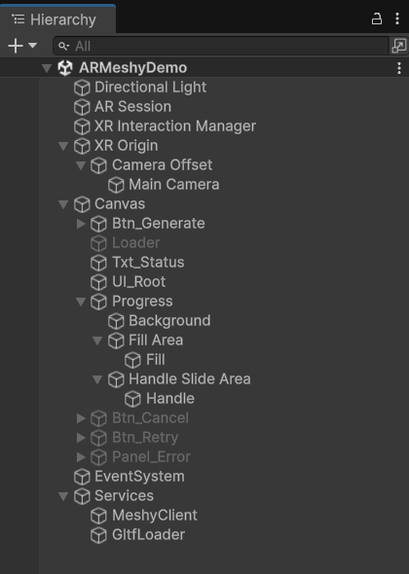
- GenerateController is the conductor:
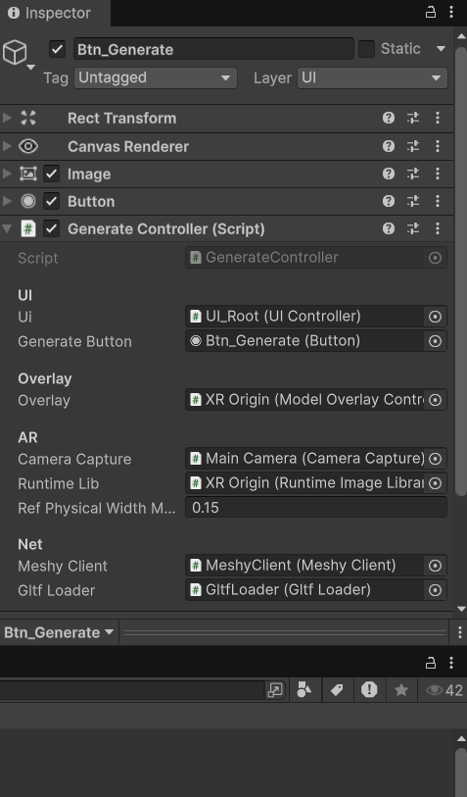
it runs the full pipeline, keeps the screen awake, shows progress, and handles cancel/retry.
- CameraCapture grabs one still. We get two outputs: JPG bytes (for upload) and a Texture2D (for tracking).
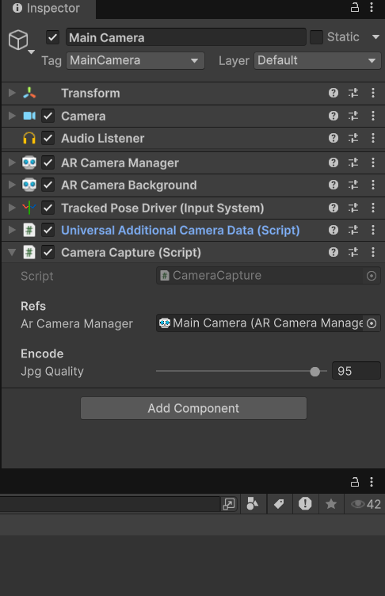
- RuntimeImageLibraryController adds that Texture2D into a mutable runtime image library with a real-world width (~0.15 m by default) and remembers CurrentRefName.
- MeshyClient creates the job and polls until 100%.
- GltfLoader downloads + loads the GLB and gives us a GameObject (we keep it inactive until tracking locks).
- ModelOverlayController listens to ARTrackedImageManager.trackedImagesChanged. When it sees our CurrentRefName with state=Tracking, it parents the model under the tracked image, scales to the page width, then makes it visible.
- UIController keeps people informed: “Capturing…”, “Uploading…”, progress %, Cancel/Retry, and a clear “Model ready ✓”.

Early configuration choices that mattered
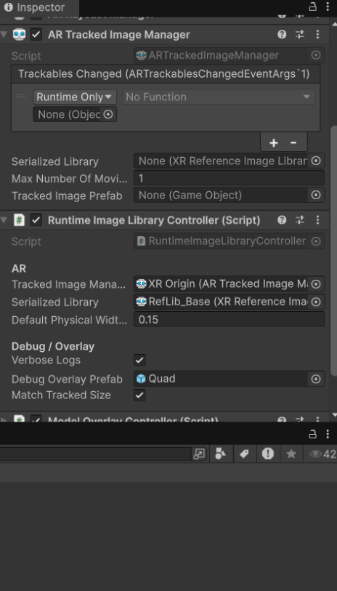
- ARTrackedImageManager sits on XR Origin. We let RuntimeImageLibraryController create/assign a mutable library at runtime and set the physical width used by AR for scale.
- We keep the loaded model hidden until we have a solid image-tracking lock. This prevents “floating” meshes before anchoring.
- We added an optional green debug quad to prove tracking is happening even before we attach the real model.
What tripped us up (and how we fixed it)
- “Model ready, but nothing shows.” Cause: after generation, the camera wasn’t looking at the same picture again, so no tracking event fired. Fix: clear instruction in the UI to point at the original picture (printed or on screen) until we get state=Tracking.
- Weak reference images. Low contrast, glare, blur, or repeating patterns score poorly and won’t track reliably. Our rule of thumb: sharp edges, decent contrast, and a physical width around 10–15+ cm in the real world work well.
- Runtime add didn’t always “take” on some devices. We added a small nudge: if needed, we reassign the runtime library or briefly disable/enable ARTrackedImageManager right after ScheduleAddImageJob completes.
Script roles at a glance
- GenerateController: orchestrates the whole flow, stores last reference name and last loaded model, exposes GetLoadedModel().
- CameraCapture: returns (jpgBytes, texture) from one still frame at chosen quality.
- RuntimeImageLibraryController: creates/assigns a MutableRuntimeReferenceImageLibrary, adds the captured Texture2D with a physical width, tracks CurrentRefName, and can spawn a debug overlay.
- MeshyClient: REST client for create-job + poll-job.
- GltfLoader: download/parse GLB, report progress, hand back a GameObject.
- ModelOverlayController: waits for image tracking, parents/scales/rotates the model, optionally locks to the first seen target and hides when tracking is lost.
- UIController: status text, progress bar, cancel and retry.

